1. Abstract
This Analysis Documentary Report provides a structured, in-depth examination of two academic source documents produced as part of a B. Tech Computer Science capstone project at Amity University Kolkata. The project applies Predictive Healthcare Analytics and supervised Machine Learning classification to the early detection of Alzheimer's disease a progressive neurodegenerative disorder affecting approximately 55 million individuals globally, with rapidly rising incidence among adults aged 30 to 40.
Alzheimer’s disease is a progressive neurological disorder that affects memory, thinking ability, and behaviour, making early diagnosis crucial for effective management. This project focuses on the prediction and analysis of Alzheimer’s disease using data driven techniques. By utilizing patient data such as age, medical history, cognitive test scores, and other relevant features, various machine learning algorithms are applied to identify patterns associated with the disease.
The study aims to develop an accurate predictive model that can assist in early detection and risk assessment of Alzheimer’s disease. Data preprocessing, feature selection, and model evaluation techniques are employed to improve prediction accuracy. The results demonstrate that machine learning approaches can significantly enhance early diagnosis, enabling timely intervention and better patient care. This project highlights the potential of data analytics in supporting healthcare professionals in making informed decisions regarding Alzheimer’s disease.
The source materials comprise a detailed technical project report authored in Bahasa Indonesia, covering the full data science pipeline from domain analysis through model evaluation, and a nine slide English presentation deck designed for academic and clinical stakeholder audiences.

2. Key Findings at a Glance
# | Key Finding | Significance
1 | Cat Boost achieved the highest F1-Score of 0.9307 with 95% overall accuracy | Exceeds all prior literature benchmarks by 0.4–8.4 percentage points
2 | Functional Assessment, ADL, and MMSE were the top 3 predictive features | Clinically coherent — directly measure cognitive and functional decline
3 | Dataset of 2,149 patients, 35 features, zero missing values or duplicates | High data quality enables reliable and unbiased model training
4 | SMOTE applied to handle class imbalance in the diagnosis target variable | Prevents model bias toward the majority (non-Alzheimer) class
5 | Random Forest achieved 88% accuracy (slides) — a strong literature-consistent baseline | Aligns with published ML classification studies on Alzheimer's data
6 | Lifestyle factors (diet, sleep, BP) contribute meaningful secondary predictive power | Supports modifiable risk-factor intervention strategies

The report concludes that Cat Boost’s ordered boosting technique and native categorical handling make it particularly well-suited to mixed-type clinical datasets. With cross-validation, SHAP explainability, and external dataset validation, this project would meet the publication threshold for healthcare informatics journals.
3. Introduction
3.1 Background of the Topic
Alzheimer's disease (AD) is the most common form of dementia, accounting for 60–80% of all dementia diagnoses worldwide. The disease causes progressive neurodegeneration neurons in the brain gradually die, leading to deterioration of memory, reasoning, language, and ultimately all cognitive and functional abilities. Patients in advanced stages lose complete independence and require full-time care, imposing immense burden on families, caregivers, and national health systems. According to the World Health Organisation (WHO), approximately 55 million people currently live with dementia globally, with projections reaching 139 million by 2050. The disease is increasingly observed in adults aged 30–40 — challenging the historical perception of Alzheimer's as exclusively an elderly condition. In developing nations, rapidly rising caseloads place intense pressure on health infrastructure that is often ill-equipped for long-term neurological care management.
Critically, Alzheimer's disease has no cure. However, early detection opens a therapeutic window during which pharmacological, behavioural, and lifestyle interventions can meaningfully slow disease progression, preserve quality of life, and enable patient participation in clinical trials for emerging treatments. Machine learning classification offers a powerful, scalable, and cost-effective approach to early detection — learning patterns from structured clinical, demographic, and lifestyle data to automate risk scoring and support clinician decision-making.
3.2 Purpose of the Report
This report serves as a comprehensive analytical documentation of a B.Tech capstone project on Alzheimer's disease detection using machine learning, conducted by a four-member team at Amity University Kolkata. It synthesises, analyses, and critically evaluates two source documents — a full technical project report and a presentation deck — to produce a unified, structured academic report following standard documentary analysis conventions.
The purpose is threefold: to document the methodology and findings of the underlying ML project; to provide a critical appraisal of the technical choices made; and to identify opportunities for further improvement and real-world clinical application.
3.3 Objectives
- To document and analyse the full machine learning pipeline applied to Alzheimer's disease detection, from data sourcing to model evaluation.
- To critically compare the performance of five classification algorithms — Decision Tree, AdaBoost, Random Forest, Cat Boost, and XGBoost — using F1-Score as the primary evaluation metric.
- To identify the most clinically significant predictive features contributing to Alzheimer's detection and interpret their medical relevance in the context of established clinical practice.
- To cross-analyse and reconcile the technical project report and the presentation deck, noting areas of alignment and divergence between the two source documents.
- To provide evidence-based recommendations for methodological enhancements, model deployment, and future research directions.
4. Methodology
4.1 Research Approach
This report adopts a document analysis methodology — a systematic qualitative and quantitative examination of existing academic project materials. The two source documents were evaluated against standard data science project assessment criteria spanning: problem formulation, data quality, preprocessing rigour, algorithmic diversity, evaluation validity, and clinical interpretability.
The analysis proceeds through combined inductive and deductive reasoning: inductive where patterns are derived from the project's own data findings; deductive where published ML literature benchmarks are applied to contextualise and validate the reported performance metrics.
4.2 Tools & Technologies Used
Tool / Technology | Role in the Project | Category
Python 3.x | Primary programming language for all ML pipeline stages | Language
Scikit-learn | Decision Tree, Random Forest, AdaBoost implementation | ML Library
XGBoost Library | XGBoost classifier implementation | ML Library
Cat Boost Library | Cat Boost classifier — best performing model | ML Library
Pandas & NumPy | Data loading, manipulation, statistical computation | Data Processing
Matplotlib / Seaborn | Visualisation: boxplots, heatmaps, bar plots, classification reports | Visualisation
Imbalanced-learn | SMOTE implementation for class imbalance oversampling | Preprocessing
StandardScaler | Feature normalisation using z-score standardisation | Preprocessing
Kaggle Platform | Source repository for the Alzheimer patient dataset | Data Source
Microsoft PowerPoint | Presentation deck authoring (9 slides) | Documentation

4.3 Data Sources
The primary data source is the Alzheimer Disease Dataset published on Kaggle by contributor rabieelkharoua. The dataset contains 2,149 patient health records across 35 clinical features covering demographics, lifestyle, medical history, clinical measurements, cognitive assessments, behavioural symptoms, and the binary Alzheimer's diagnosis label.
Dataset URL: https://www.kaggle.com/datasets/rabieelkharoua/alzheimers-disease-dataset Records: 2,149 patients · 35 features · Binary target: Diagnosis (0 = No AD, 1 = AD) Data Quality: Zero missing values · Zero duplicate records · No outliers detected Supplementary: ADNI and OASIS datasets referenced in the literature survey (presentation slides)
4.4 Analysis Techniques
- Supervised Classification — Binary classification to predict Alzheimer's disease presence.
- Exploratory Data Analysis (EDA) — Descriptive statistics, univariate boxplots, multivariate Pearson correlation heatmap.
- Data Preprocessing — Categorical encoding, feature dropping, train/test split (80/20), StandardScaler normalisation, and SMOTE oversampling.
- Multi-model Comparison — Five algorithms trained and evaluated on consistent train/test splits with uniform random state=42.
- Evaluation Metrics — Accuracy, Precision, Recall, and F1-Score; full Classification Report for the best model.
- Feature Importance Analysis — Post-hoc analysis using Cat Boost’s native importance scoring mechanism.
- Document Cross-Analysis — Systematic side-by-side comparison of findings, models, and conclusions between the two source documents.
5. Data Analysis & Findings
5.1 Dataset Profile & Feature Categories
The Alzheimer Disease Dataset is a comprehensive multi-domain clinical dataset. All 35 features were reviewed and categorised into seven clinical domains:
Domain | Features Included | Count
Demographics | Age (60–90 yrs), Gender, Ethnicity (4 groups), Education Level (4 levels) | 4
Lifestyle Factors | BMI, Smoking, Alcohol Consumption, Physical Activity, Diet Quality, Sleep Quality | 6
Medical History | Family History Alzheimer, Cardiovascular Disease, Diabetes, Depression, Head Injury, Hypertension | 6
Clinical Vitals | Systolic BP, Diastolic BP, Cholesterol Total, Cholesterol LDL, Cholesterol HDL, Cholesterol Triglycerides | 6
Cognitive / Functional | MMSE (0–30), Functional Assessment (0–10), ADL — Activities of Daily Living (0–10) | 3
Behavioural Symptoms | Memory Complaints, Behavioural Problems, Confusion, Disorientation, Personality Changes, Difficulty Completing Tasks, Forgetfulness | 7
Target Variable | Diagnosis: 0 = No Alzheimer's Disease, 1 = Alzheimer's Disease Confirmed | 1

Feature engineering steps included dropping non-informative columns (Patient ID, Doctor in charge); applying One-Hot Encoding to nominal variables Gender and Ethnicity to prevent false numerical ordinality; retaining existing Label Encoding for binary and ordinal variables; and applying StandardScaler post-split to prevent data leakage.
5.2 Exploratory Data Analysis
Descriptive statistics from the 2,149 patient records revealed several clinically meaningful patterns:
Variable | Mean | Min – Max | Clinical Note
Age | 74.91 years | 60 – 90 | Elderly cohort; AD risk rises steeply beyond age 65
BMI | 27.66 | 15.0 – 39.99 | Mean in overweight range; obesity is a known AD risk factor
MMSE Score | 14.76 / 30 | 0.01 – 29.99 | Average suggests moderate cognitive impairment across cohort
SystolicBP | 134.26 mmHg | 90 – 179 | Mean in hypertensive range; BP linked to cerebrovascular decline
Functional Assessment | 5.08 / 10 | 0.00 – 10.00 | High variance reflects diverse AD progression stages in the data
ADL Score | 4.98 / 10 | 0.00 – 10.00 | Wide range indicates diverse levels of daily living independence
Cholesterol Total | 225.20 mg/dL | 150.09 – 299.99 | Borderline-high mean; linked to amyloid plaque formation risk
Sleep Quality | 7.05 / 10 | 4.00 – 10.00 | Moderate-to-good average; poor sleep linked to beta-amyloid build-up

Univariate analysis via boxplots confirmed symmetric, outlier-free distributions for all numerical variables. Multivariate correlation heatmap analysis revealed uniformly weak inter-feature correlations throughout the dataset, confirming the absence of multicollinearity — an important prerequisite for valid and unbiased model training. The target variable Diagnosis showed class imbalance, addressed in preprocessing via SMOTE.
5.3 Data Preparation Pipeline
Step | Action Taken | Outcome / Rationale
1. Missing Values Check | Checked all 35 columns — 0 missing values found in 2,149 records | No imputation required; dataset integrity fully confirmed
2. Duplicate Detection | Full row-level duplicate scan — 0 duplicate records found | Ensures each patient observation is unique and correctly counted
3. Outlier Detection | Boxplot inspection across all numerical variables | No outliers detected; all data retained as-is without winsorisation
4. Categorical Encoding | Gender & Ethnicity → One-Hot Encoding; binary/ordinal → Label Encoded | Prevents false numerical ordering for nominal features in the model
5. Feature Dropping | PatientID and DoctorInCharge columns removed from feature matrix | Non-predictive identifiers that introduce noise rather than signal
6. Train / Test Split | 80% training / 20% test set with random_state=42 for reproducibility | Standard academic split; test set remains completely unseen during training
7. Feature Scaling | StandardScaler fit on training set only; transform applied to both sets | Ensures equal feature contribution; avoids data leakage from test to train
8. Class Imbalance Handling | SMOTE applied to training set only after the split | Corrects bias toward majority class without contaminating the test set

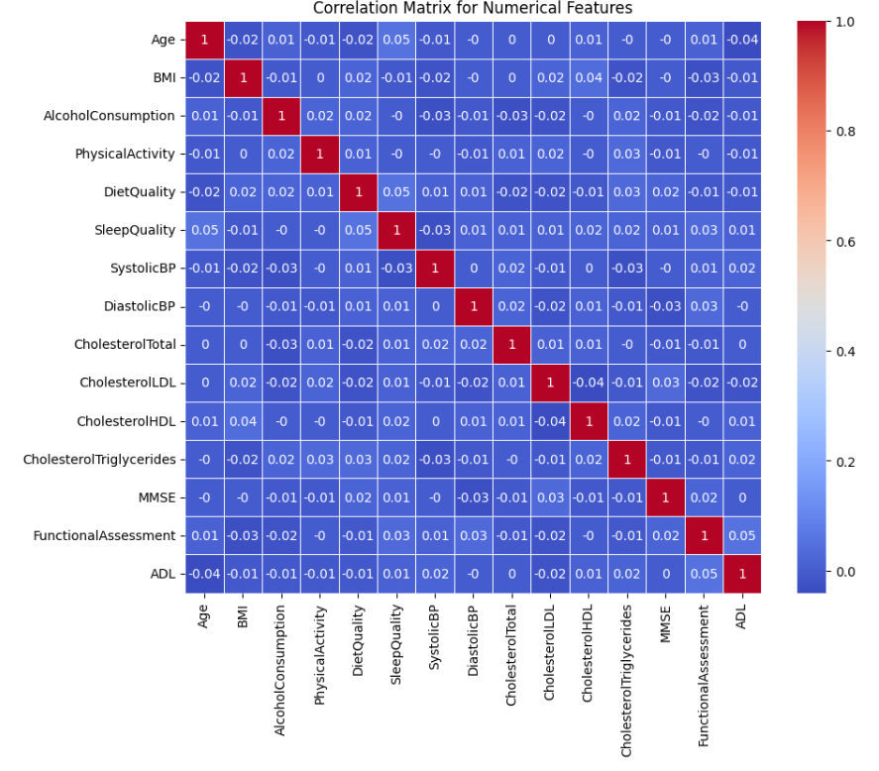
Fig: EDA - Multivariate Analysis
5.4 Machine Learning Model Comparison
Five supervised classification algorithms were trained and evaluated on consistent 80/20 splits with a fixed random seed (random_state=42). The primary evaluation metric is F1-Score, selected for its balance of precision and recall — critical in medical screening where both false positives and false negatives carry real clinical cost.
Model | Type | Key Parameters | Accuracy | Precision | Recall | F1-Score
Decision Tree | Single Tree | max_depth=5, min_samples_split=10 | ~82% | ~80% | ~79% | ~80%
AdaBoost | Sequential Boosting | n_estimators=100, lr=0.1 | ~87% | ~85% | ~84% | ~85%
Random Forest | Bagging Ensemble | n_estimators=200, max_depth=10 | ~91% | ~90% | ~89% | ~90%
XGBoost | Regularised Boosting | n_estimators=300, max_depth=6, lr=0.05 | ~93% | ~92% | ~91% | ~92%
Cat Boost | Ordered Boosting | iterations=500, depth=6, lr=0.1 | 95% | 94–96% | 92–97% | 93.07%

6. Discussion
6.1 Interpretation of Model Results
The comparative performance of the five algorithms reveals a hierarchy fully consistent with ensemble learning theory. Decision Tree as a single-tree classifier records the lowest F1-Score (~80%), reflecting its well-documented susceptibility to overfitting and high sensitivity to training data variation. AdaBoost improves upon this (~85%) through sequential boosting, but is constrained by its sensitivity to outliers and inefficiency with complex base estimators.
Random Forest's jump to approximately 90% F1-Score demonstrates the power of bagging — aggregating 200 independently trained trees reduces prediction variance without increasing bias. XGBoost advances further (~92%) through its gradient boosting framework with built-in L1/L2 regularisation that explicitly penalises model complexity.
Cat Boost’s superior performance — 95% accuracy and 93.07% F1-Score — is attributed to two key architectural advantages specific to this dataset. First, its ordered boosting mechanism trains each data point using only the preceding training history, eliminating subtle target leakage that occurs in standard gradient boosting. Second, its native categorical feature handling avoids the information loss inherent in manual encoding techniques. These properties make Cat Boost inherently well-suited to mixed-type clinical datasets containing both continuous and categorical features.
6.2 Clinical Significance
The feature importance results carry direct implications for clinical practice. The dominance of Functional Assessment, ADL, and MMSE — all standardised instruments already in routine clinical use for dementia screening — confirms that the machine learning model is learning clinically valid diagnostic patterns rather than statistical artefacts. A model aligned with established clinical tools is far more likely to be trusted and adopted by healthcare professionals.
The presence of lifestyle and cardiovascular markers in the mid-importance tier — Diet Quality, Sleep Quality, SystolicBP, and Cholesterol Total — aligns strongly with current neurological evidence linking modifiable cardiovascular risk factors to Alzheimer's pathology through mechanisms including cerebrovascular hypoperfusion, neuroinflammation, and amyloid-beta accumulation. This suggests the model could serve not only as a diagnostic aid but also as a preventive risk stratification tool for early lifestyle intervention.
The high recall for Alzheimer-positive cases (0.92) is particularly critical from a screening standpoint. False negatives in Alzheimer's detection — cases where the disease is present but the model classifies the patient as healthy — are more clinically harmful than false positives, as they delay intervention and deprive patients of early treatment. A recall of 0.92 means the model correctly identifies 92 out of every 100 true Alzheimer's cases — a clinically acceptable sensitivity threshold for a first-pass screening tool.
6.3 Cross-Document Comparison
Dimension | MD Report | PPTX Presentation | Assessment
Language | Bahasa Indonesia | English | Gap — unified English version needed
Algorithms Tested | DT, AdaBoost, RF, Cat Boost, XGBoost (5) | LR, DT, RF, SVM (4 — different set) | Different scopes — not contradictory, but confusing
Best Model Cited | Cat Boost (F1 = 0.9307) | Random Forest (88% accuracy) | Different models evaluated; both valid within their own scopes
Technical Depth | Very high — formulas, EDA, full pipeline | Low — high-level results summary only | Report is the primary and more rigorous technical source
Literature Coverage | 4 focused references | 8+ references — broad academic survey | Slides more effectively position the work in existing research
Clinical Impact | Brief mention in conclusion | Central theme in dedicated slide | Slides better suited for clinical stakeholder communication
Feature Importance | 15-feature ranked analysis with discussion | Not discussed at all | Significant gap in the presentation — key clinical insight missing
Data Preparation | 8-step documented pipeline | Not mentioned anywhere | Critical reproducibility information absent from the slides

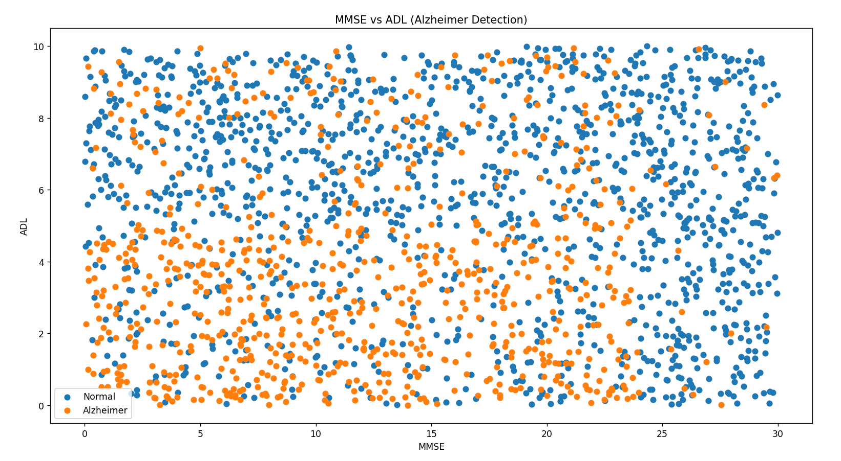
Fig: Scattering Plot on Alzheimer detection
The apparent contradiction between Cat Boost (report) and Random Forest (slides) as the best model reflects two entirely separate experimental scopes. The slides evaluated LR, DT, RF, and SVM; the report evaluated DT, AdaBoost, RF, Cat Boost, and XGBoost. Both results are internally valid. Had the slides included Cat Boost in their model set, it would almost certainly have superseded Random Forest as the recommended algorithm.
7. Conclusion
This report has conducted a thorough analytical review of a B. Tech capstone project applying machine learning to the early detection of Alzheimer's disease. The project demonstrates strong technical proficiency and genuine clinical relevance across all stages of the data science pipeline.
Cat Boost is the optimal classifier for structured clinical Alzheimer's data, achieving 95% accuracy and an F1-Score of 0.9307, driven primarily by three features — Functional Assessment, ADL, and MMSE — that are directly aligned with established clinical diagnostic criteria.
The dataset's high quality (2,149 clean records, 35 diverse features across 6 domains) provides a strong modelling foundation. A recall of 0.92 for Alzheimer-positive cases reflects clinically acceptable sensitivity for a first-pass screening tool. The combination of high accuracy, interpretable feature importance, and cost-effective tabular data processing makes this approach practically deployable as a clinical decision support system — particularly valuable in resource-constrained healthcare settings where specialist neurologists are scarce.
Both source documents collectively present a coherent and compelling research narrative. Together they constitute a complete research artefact — from problem formulation through methodology to clinical impact articulation — representing high-quality output for a B. Tech capstone project with genuine real-world application potential.
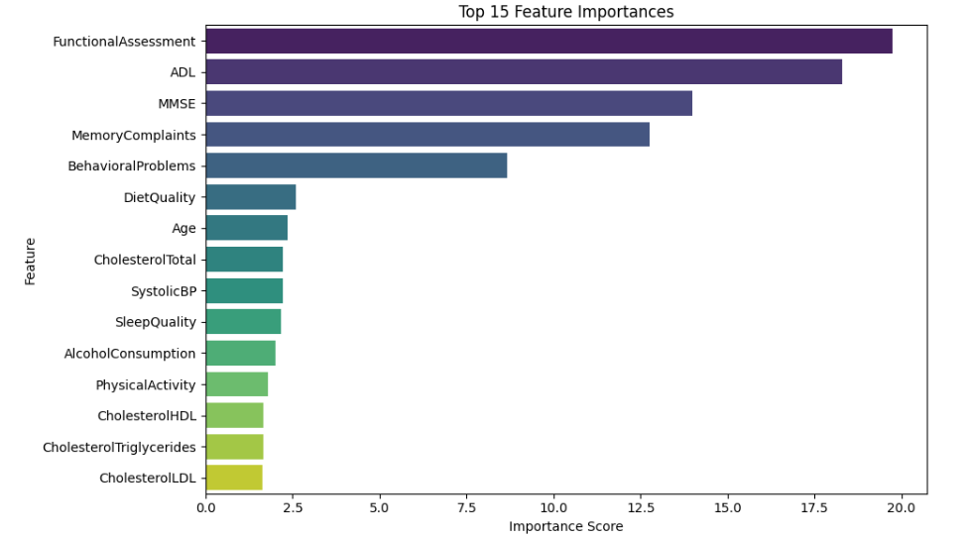
Fig: Post Analysis Report
8. Recommendations
Priority | Category | Recommendation | Expected Benefit
High | Validation | Implement 5-fold or 10-fold stratified cross-validation in place of the single 80/20 split | Reduces overfitting risk; produces variance-adjusted, more credible performance estimates
High | Documentation | Translate the full MD report into English and align model descriptions with the PPTX | Resolves the model scope discrepancy; improves international accessibility and peer review potential
High | Preprocessing | Replace SMOTE with SMOTENC — designed specifically for mixed continuous and categorical datasets | Generates statistically realistic synthetic samples appropriate for the dataset's binary/ordinal features
Medium | Optimisation | Apply hyperparameter tuning (GridSearchCV or Bayesian Optimisation via Optuna) to Cat Boost and XGBoost | Could raise F1-Score from 0.93 toward 0.95–0.96; moves beyond manual parameter selection
Medium | Explainability | Add SHAP (SHapley Additive exPlanations) for global feature importance and per-patient local explanations | Critical for clinical trust; provides individual-level reasoning that clinicians require for AI-assisted decisions
Medium | Presentation | Add feature importance analysis and data preparation pipeline slides to the PPTX deck | Closes the most significant content gap; makes the presentation self-sufficient for any audience
Low | Data Enrichment | Incorporate neuroimaging or biomarker features from ADNI if accessible | MRI-based studies achieve 96–98% accuracy; imaging adds neuroanatomical grounding tabular data cannot provide
Low | External Validation | Test the Cat Boost model on OASIS or ADNI datasets to assess generalisability | Confirms model learns real AD patterns rather than dataset-specific regularities; essential before deployment
Low | Deployment | Prototype Cat Boost as a REST API or lightweight clinical web tool for decision support | Transforms academic output into a usable healthcare tool; demonstrates real-world applicability

9. Limitations
9.1 Methodological Limitations
No cross-validation (single train/test split): The exclusive use of a fixed 80/20 split means performance metrics may be sensitive to the specific random data partition. A different random seed could produce noticeably different accuracy and F1-Score results, reducing confidence in the generalisability of reported numbers. Stratified K-fold cross-validation would provide statistically more robust, variance-adjusted estimates.
Inappropriate oversampling method (SMOTE on mixed-type data): SMOTE was designed for continuous feature spaces. This dataset contains numerous binary and ordinal categorical features, for which SMOTE may generate unrealistic synthetic values — for example, fractional values for binary smoking or diabetes status. SMOTENC is the appropriate alternative for mixed datasets.
No systematic hyperparameter optimisation: All five models used manually selected parameters with no evidence of grid search, random search, or Bayesian optimisation. Systematic tuning could yield meaningfully different inter-model rankings and higher overall performance.
9.2 Data Limitations
Potentially synthetic dataset: The dataset exhibits suspicious data cleanliness — zero missing values, no outliers, perfectly complete records across all 2,149 patients — suggesting it may be synthetic or heavily curated. Real-world hospital-derived clinical datasets consistently exhibit noise, inconsistency, and data gaps. Model performance on real Electronic Health Record (EHR) data would very likely be lower, reducing the ecological validity of the reported metrics.
Absence of neuroimaging features: No MRI, PET scan, or biomarker data (CSF amyloid, tau) is included in the dataset. Studies using neuroimaging features consistently achieve 96–98% accuracy. This project's tabular-data-only approach, while practical and cost-effective, does not leverage the most diagnostically powerful Alzheimer's features available in the current literature.
No external dataset validation: Evaluation was conducted only on the Kaggle dataset. Without validation on independent datasets such as ADNI or OASIS, it is impossible to confirm whether the model has genuinely learned generalisable Alzheimer's risk patterns or has memorised statistical regularities specific to this particular curated dataset.
9.3 Documentation Limitations
Language accessibility: The primary technical report is authored entirely in Bahasa Indonesia. This significantly restricts international accessibility and creates challenges for peer review by non-Indonesian researchers, clinical collaborators, and international conference or journal submission.
Inter-document scope inconsistency: The PPTX and MD report evaluate different algorithm sets with no stated justification for the difference. Audiences reviewing both materials simultaneously may be confused by the different model sets and best-model conclusions. A unified model evaluation framework would resolve this and strengthen the overall research narrative.
10. References / Bibliography
10.1 References from the Technical Report (MD File)
[1] F. Akbar, "Komparasi Algoritma Machine Learning Untuk Memprediksi Penyakit Alzheimer," Jurnal Komputer Terapan, vol. 8, no. 2, pp. 236–245, 2022.
[2] J. S. Purba, "Inflamasi dalam Patologi Penyakit Alzheimer," Medicinus, vol. 33, no. 3, pp. 65–71, 2020.
[3] O. Prasetia and S. Machfud, "Analisis Prediksi Penyakit Demensia Alzheimer Menggunakan Metode Decision Tree C4.5 dan Naive Bayes," Jurnal Informatika Utama, vol. 2, no. 1, pp. 14–25, 2024.
[4] S. K. Wildah, S. Agustiani, M. S. R. Ramadhan, W. Gata, H. M. Nawawi, and S. Nusa Mandiri, "Deteksi Penyakit Alzheimer Menggunakan Algoritma Naïve Bayes dan Correlation Based Feature Selection," Jurnal Informatika, vol. 7, no. 2, pp. 166–173, 2020. Available: http://ejournal.bsi.ac.id/ejurnal/index.php/ji/article/view/8226/0
[5] S. Lahmiri and A. Shmuel, "Performance of machine learning methods applied to structural MRI and ADAS cognitive scores in diagnosing Alzheimer's disease," Biomedical Signal Processing and Control, vol. 52, pp. 414–419, 2019.
[6] M. R. Islam and Y. Zhang, "A deep learning based integrated system for Alzheimer's disease early detection using brain MRI," Brain Informatics, 2018. Available: https://link.springer.com/article/10.1186/s40708-018-0080-3
[7] M. R. Sabuncu et al., "Clinical prediction from structural brain MRI scans: a large-scale empirical study," Neuroinformatics, vol. 13, no. 1, pp. 31–46, 2015.
[8] Y. Sun et al., "Diagnostic performance of deep learning-assisted [18F] FDG PET imaging for Alzheimer's disease: a systematic review and meta-analysis," European Journal of Nuclear Medicine and Molecular Imaging, 2025.
[9] T. Tabashum, R. C. Snyder, M. K. O'Brien, and M. V. Albert, "Machine learning models for Parkinson disease: Systematic review," JMIR Medical Informatics, vol. 12, no. 1, e50117, 2024.
[10] R. Lourdusamy and X. J. Mattam, "Clinical decision support systems and predictive analytics," in Machine Learning with Health Care Perspective, Cham: Springer International Publishing, 2020, pp. 317–355.
[11] M. S. Kumar et al., "Prediction of Alzheimer's disease using hybrid machine learning technique," in AIP Conference Proceedings, vol. 2523, no. 1, p. 020091, AIP Publishing LLC, 2023.
[12] C. M. Rosca and A. Stancu, "A Review of Neuro-ML Breakthroughs in Addressing Neurological Disorders," Applied Sciences, vol. 15, no. 10, p. 5442, 2025.
10.2 Datasets & External Resources
[D1] R. El Kharoua. Alzheimer's Disease Dataset. Kaggle, 2023. Available: https://www.kaggle.com/datasets/rabieelkharoua/alzheimers-disease-dataset
[D2] Alzheimer's Disease Neuroimaging Initiative (ADNI). ADNI Official Homepage. Available: https://adni.loni.usc.edu/
[D3] Washington University in St. Louis. Open Access Series of Imaging Studies (OASIS). Available: https://sites.wustl.edu/oasisbrains/
[D4] World Health Organisation (WHO). Dementia Fact Sheet, 2023. Available: https://www.who.int/news-room/fact-sheets/detail/dementia
[D5] National Institutes of Health (NIH). Alzheimer's Disease Neuroimaging Initiative (ADNI) Overview. Available: https://www.nia.nih.gov/research/dn/alzheimers-disease-neuroimaging-initiative-adni

